***AEC LAB REPORT – 3***

***Full Wave Rectifiers***

***NAME:*** *Khyathi Sri Basireddy*

***ROLL NO****: 2023102065*

***TABLE NO****: 9*

***1.*** ***Transformer Characterization***

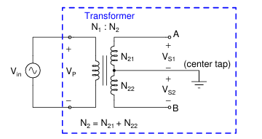

VP / VS = N1 / N2

VS = VA −VB,

N2 = N21 +N22

**(a) Values of VA and VB**

Vin = 12 Vpp

Frequency = 1kHz

Channel 1 - VA

Channel 2 - Vb

Report of VA: Amplitude = 440mV

Frequency = 1kHz

Report of VB: Amplitude = 440mV

Frequency = 1kHz

Phase Difference between VA and VB = 180 degrees.

The picture below shows the peak to peak value of amplitude.

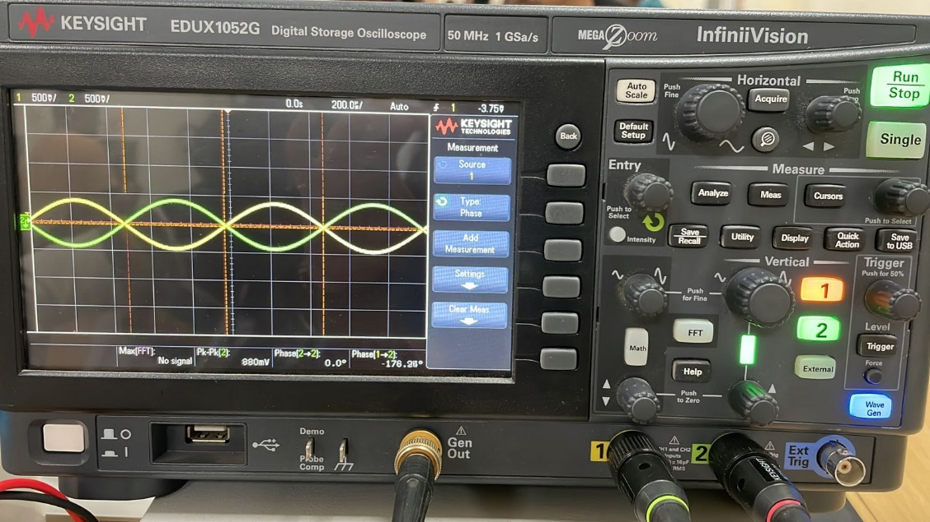

**(b) Amplitude, Phase and N1:N2**

Vin = 12 Vpp

Report of VA: Amplitude = 440mV

Frequency = 1kHz

Report of VB: Amplitude = 440mV

Frequency = 1kHz

Phase Difference between VA and VB = 180 degrees.

Vp = 12 Vpp

Vs = Va – Vb

= 440 – (-440) mV

= 880 mV

N1:N2 = Vp : Vs

= 12/880m

= 13.6

Hence the no of turns in the primary coil to that in secondary coil is 13.6.

**(c) Change in frequency of Vin**

|  |  |
| --- | --- |
| ***Frequency*** | ***VA Output*** |
| 10 kHz | 440 mV |
| 50 kHz | 425 mV |
| 100 kHz | 415 mV |
| 1 MHz | 0.61V |
| 5 MHz | 0.77V |
| 10 MHz | 0.85V |
| 20 MHz | 10 mV |

As we increase the frequency, we can see that the amplitude at A slowly starts decreasing and then gain starts to increase an gain decreases.

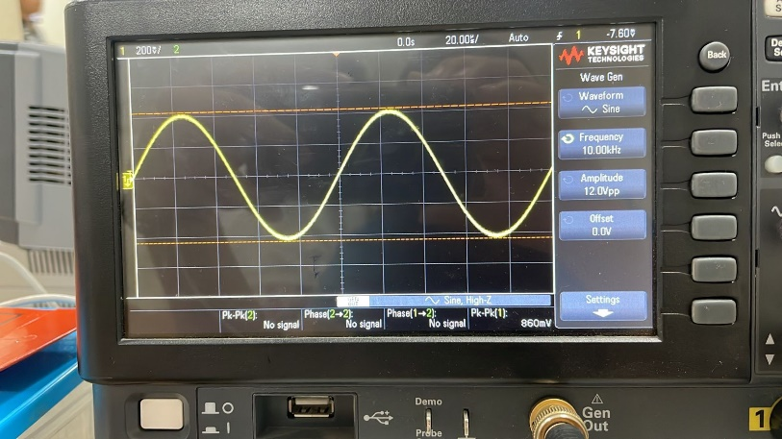 F = 10 kHz

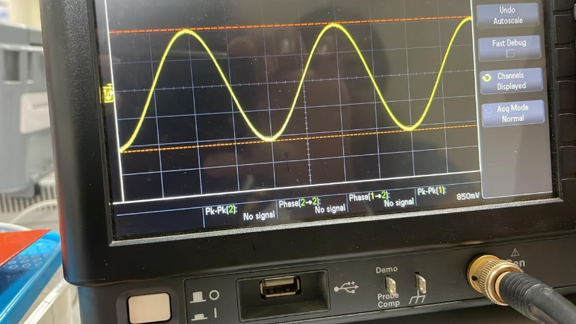 F = 50 kHz

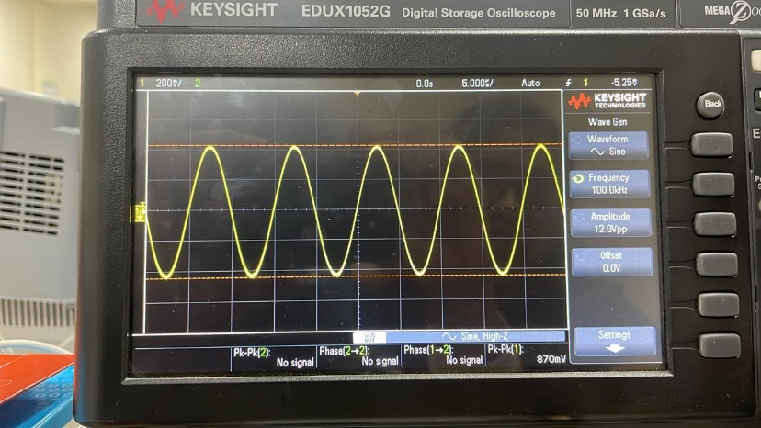 F= 100 kHz

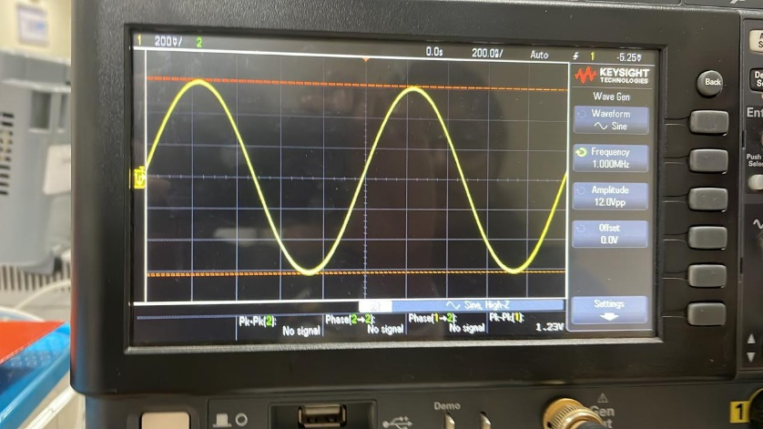 F = 1 MHz

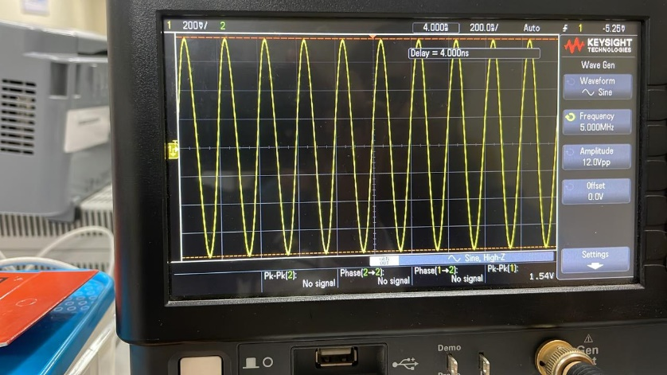 F = 5 MHz

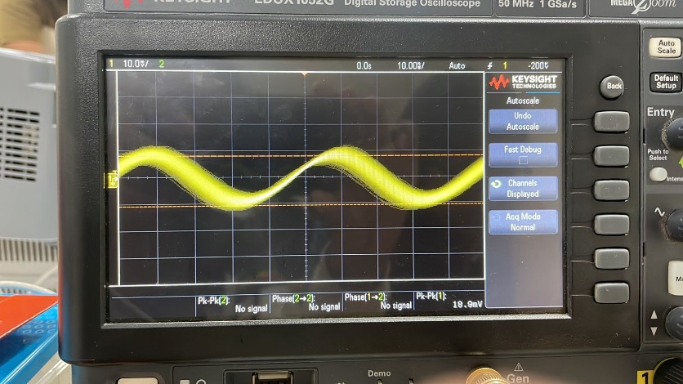 F = 20MHz

**(d) Reduction in Input Side Amplitude**

|  |  |  |
| --- | --- | --- |
| **Frequency** | **Vin** | **Vin Observed** |
| 10 kHz | 12V | 11.93V |
| 50 kHz | 12V | 11.92V |
| 100 kHz | 12V | 11.92V |
| 1 MHz | 12V | 11.87V |
| 5 MHz | 12V | 8.5V |
| 10 MHz | 12V | 4.25V |
| 20 MHz | 12V | 2.85V |

Yes, from the above table it is clear that there is an evident decrease in the amplitude with increase in frequency.

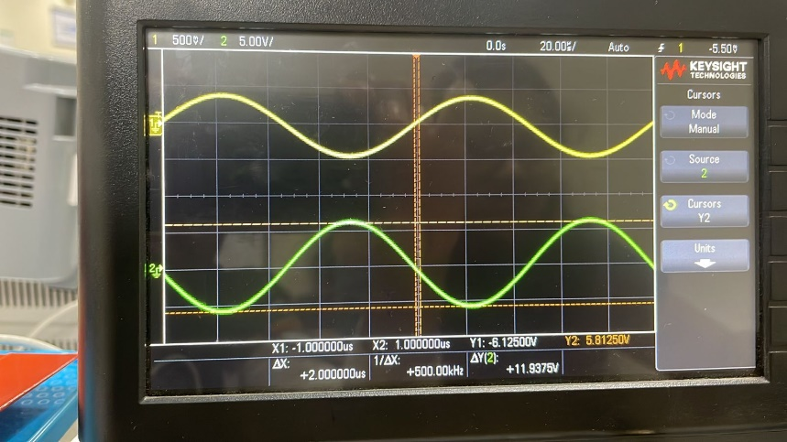 F = 10 kHz

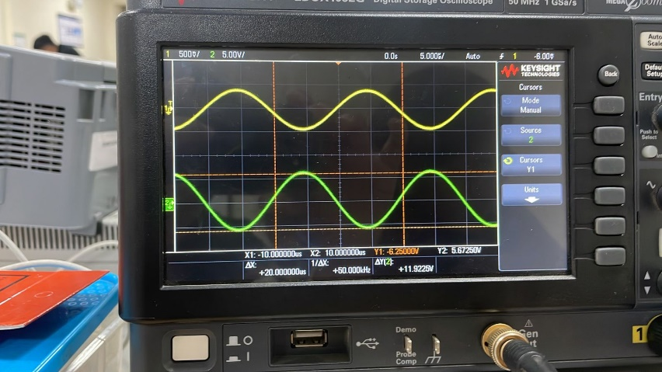 F = 50 kHz

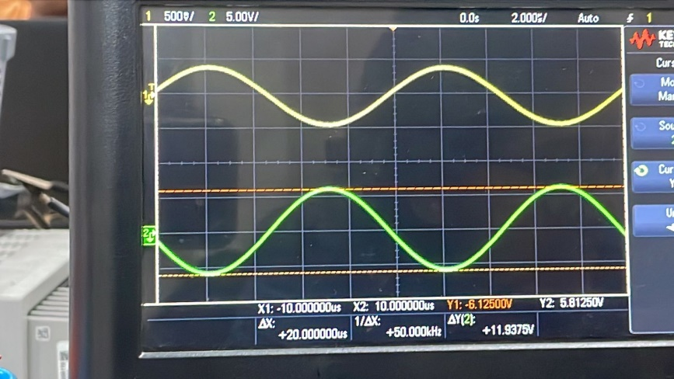 F = 100 kHz

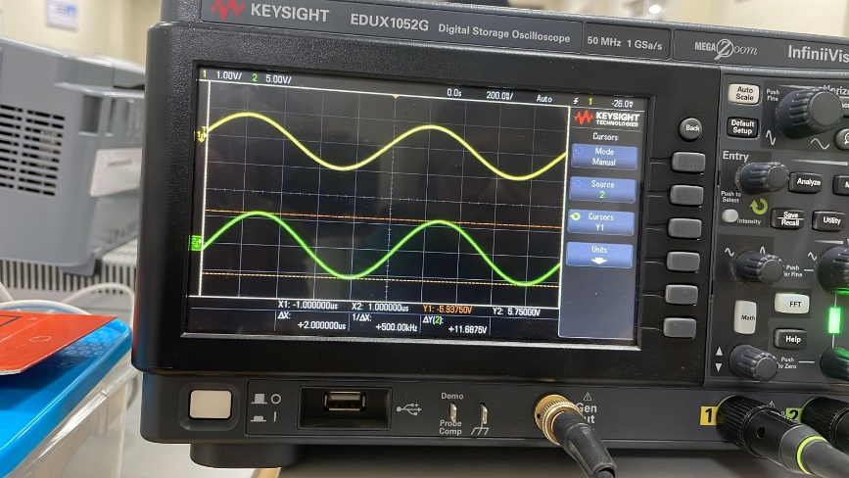 F = 1 MHz

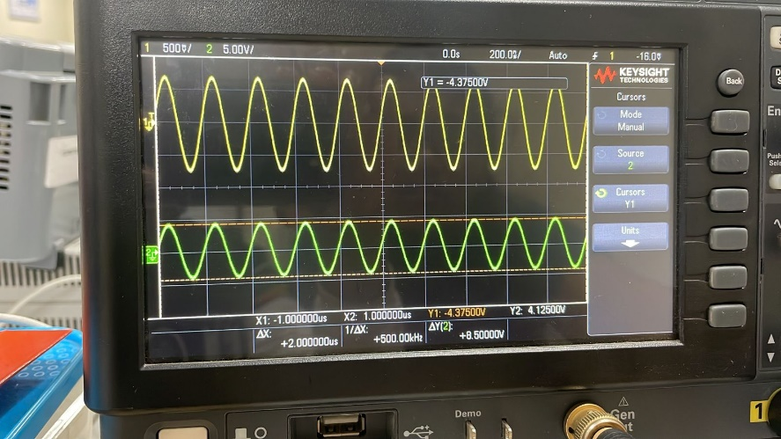 F = 5 MHz 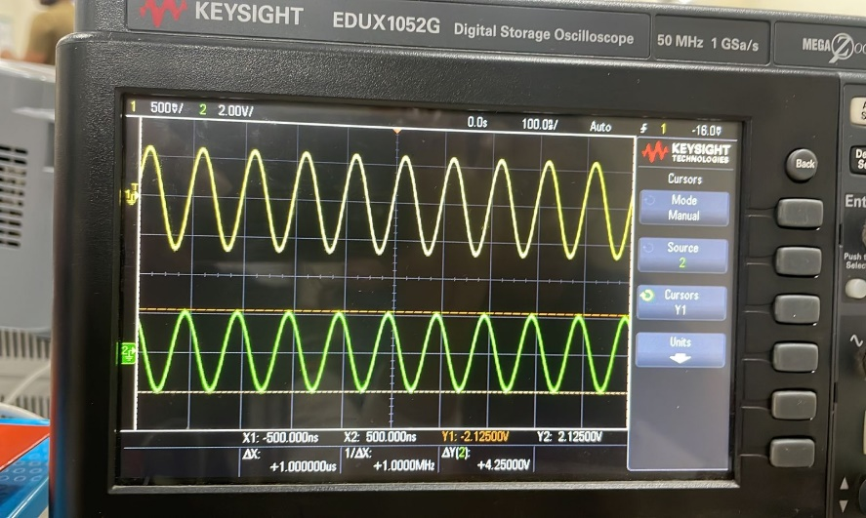 F = 10 MHz

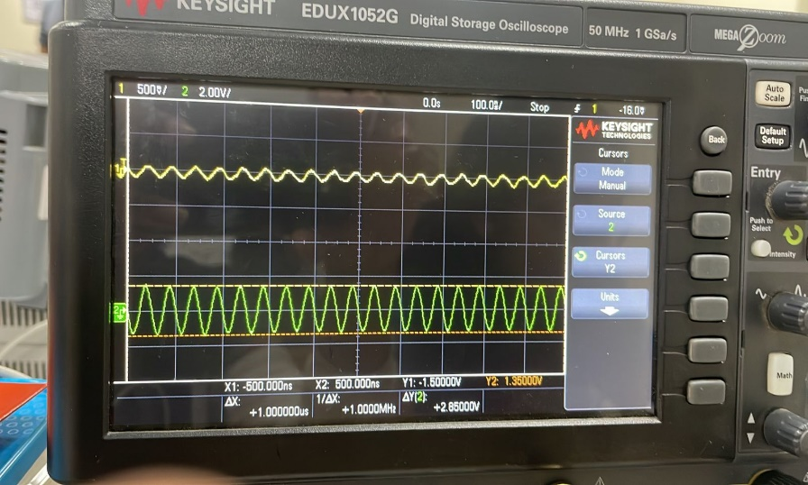 F = 20 MHz

**Reduction in VA with increase in frequency:**

* The most probable cause for this is because of all the resistance and capacitance/impedance that is offered by the probe wires effects the output.
* At higher frequencies, the impedance of the cable rises, resulting in signal attenuation or reduction in the signal amplitude
* Also, even when the bandwidth of input cable is limited, this can result in decrease in the amplitude.

**Reduction in Vin with increase in frequency:**

* The input cable has a limited bandwidth, because of which the signal can be attenuated.
* The transformer may resonate at a particular frequency, causing a reduction in the output voltage at that frequency.

**(e) -3dB Bandwidth**

We know that the -3dB bandwidth of the cable is obtained at an amplitude which is 1/root 2 times of Vin.

V’ = Vin / 1.414

= 12 / 1.414

= 8.48 V

Frequency at V = 8.48V is **4.9 MHz**

It is clearly shown in the picture and data below.

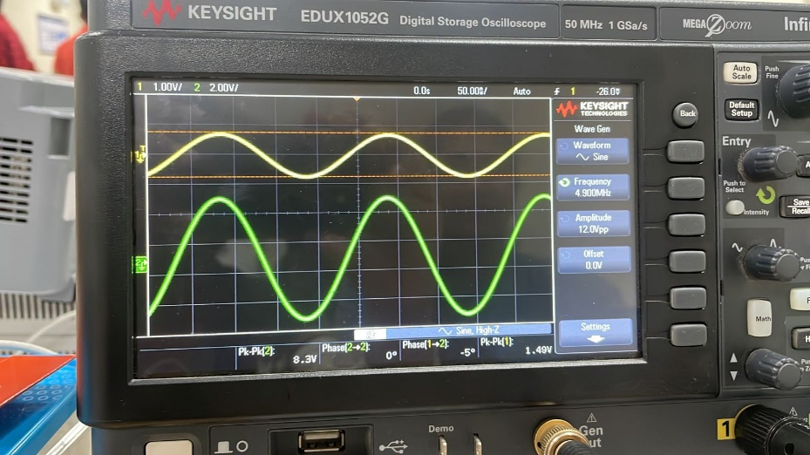

***2.*** **Full Wave Rectifier (FWR) using centre tap transformer and two diodes**

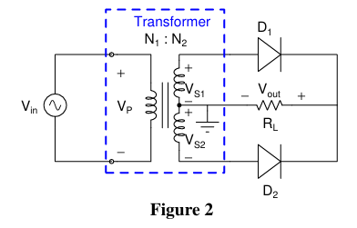

**(a) Connecting the circuit**

Vin = 12 Vpp

f = 1 kHz

RL = 50 k ohm

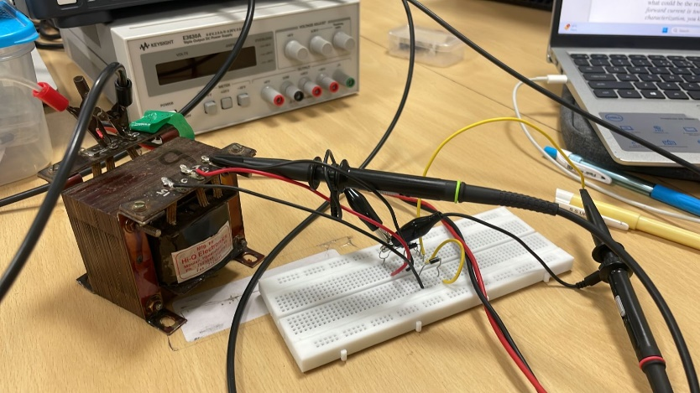

**(b) Plots of Vs1 and Vout**

Vs1 = 880/2 mV (yellow graph)

= 440 mV

Vout = 130/2 mV (green graph)

= 65 mV

Yes, we do observe the full wave rectification.

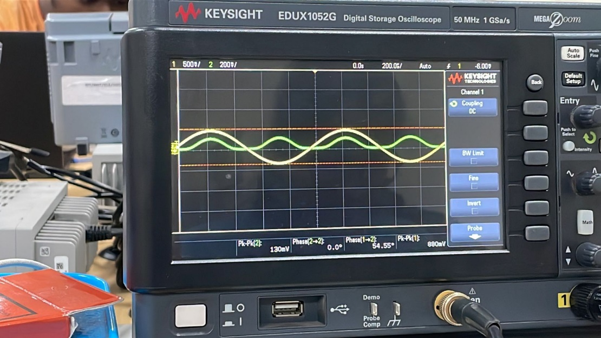

**(c) Peak Current**

Peak Current flowing through RL is

IL = Vout / RL

= 65 mV / 50 k ohm

= 1.3 uA

**(d)Reduction in Vout**

Vin = 12 Vpp

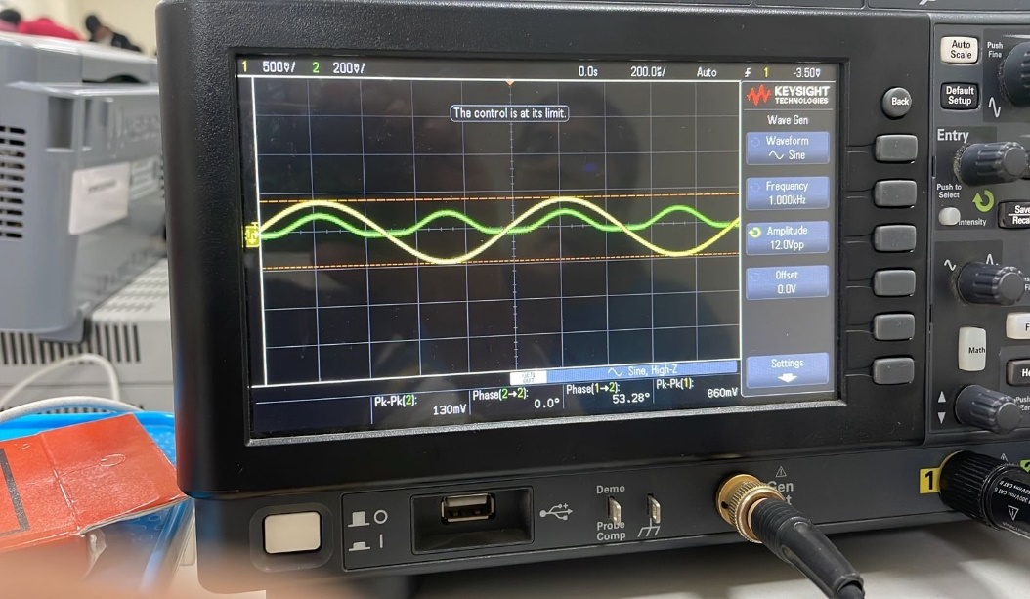

Vin = 9 Vpp

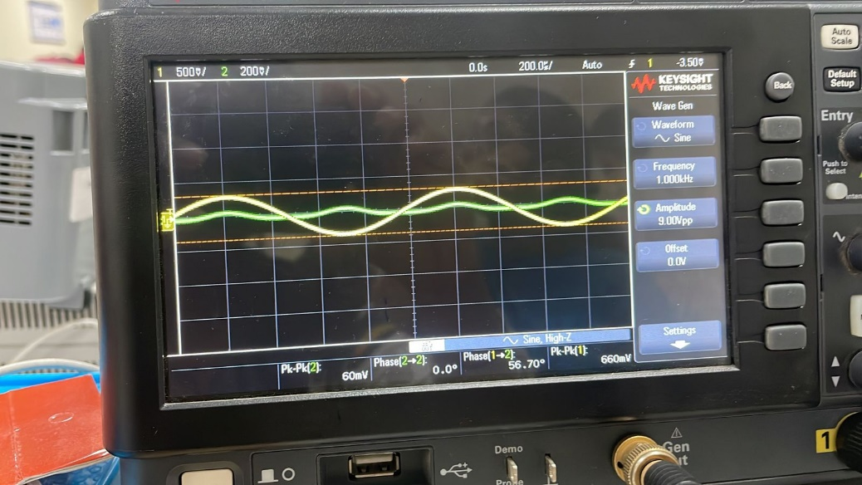

Vin = 6.4 Vpp

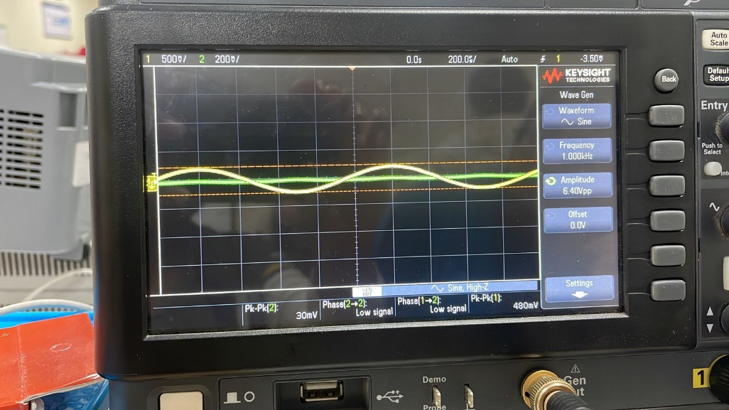

**Reason:**

The Vout remains negligable for a while that is almost very small like 30 mV until the cutin voltage of the diode. Once this voltage is reached, then slowly the Vout starts to increase.

Until the cutin/threshold voltage is reached Diodes might not be able to completely turn on and forward current is too less.

**3. Bridge rectifier for full wave rectification**

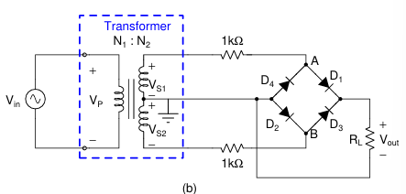

**(a) Connecting the Circuit to WaveGen**

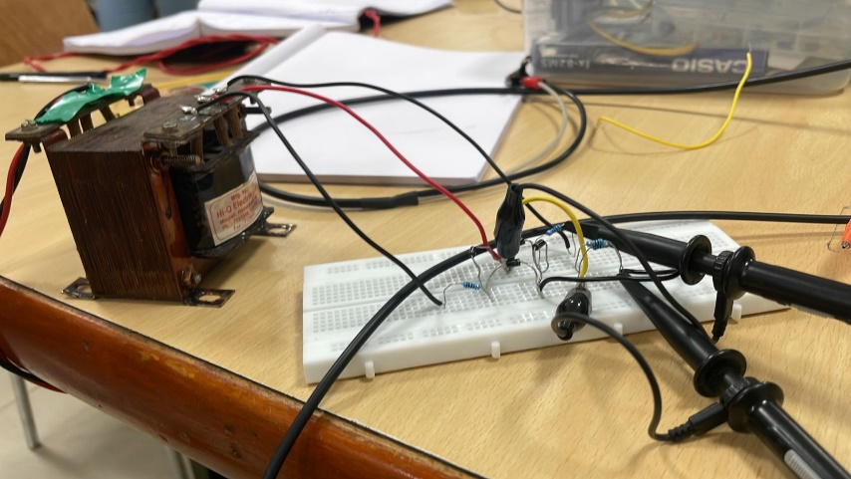

Vin = 12 Vpp

f = 1 kHz

RL = 50 k ohm

(b)

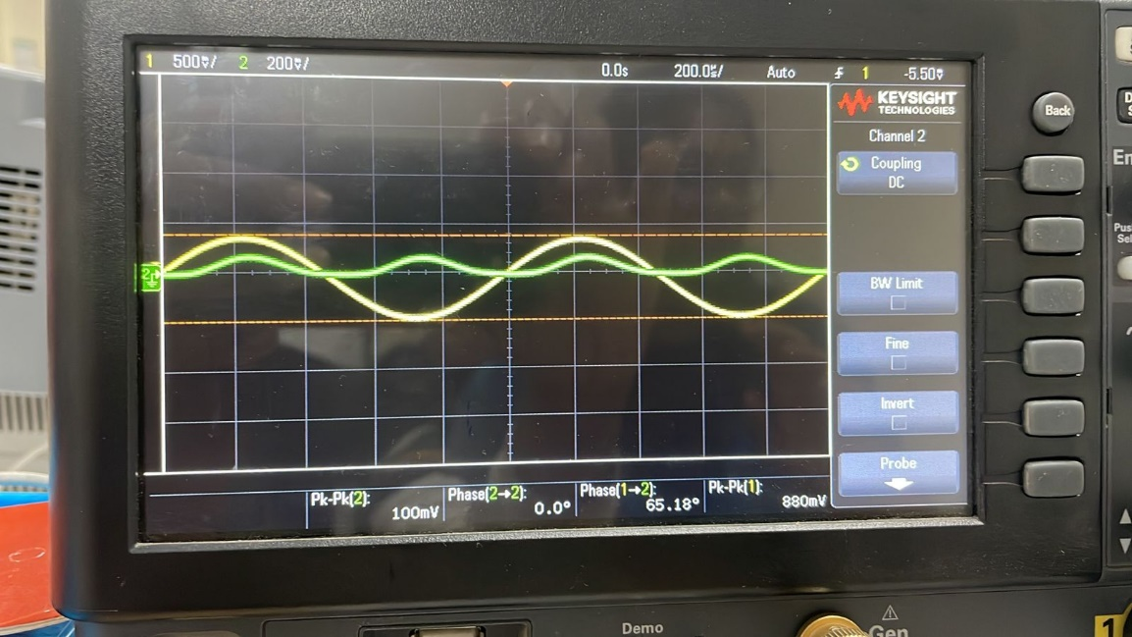

From the above graph,

Vs1 = 880/2 mv (yellow line)

= 440 mV

Vout = 100/2 mV

= 50 mV

Peak Current through RL , IL = Vout / RL

= 50 mV / 50 k ohm

= 1 uA

**(c) Transformer with Wall supply**

**Vs1 vs Vs2**

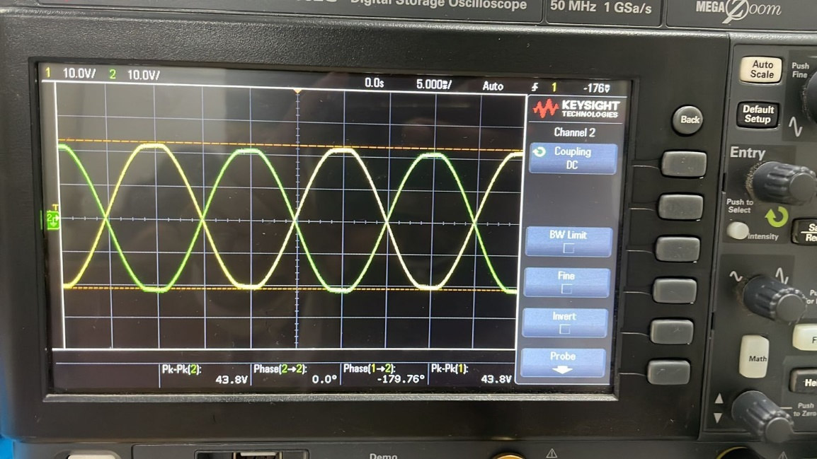

**VS1 and Vout**

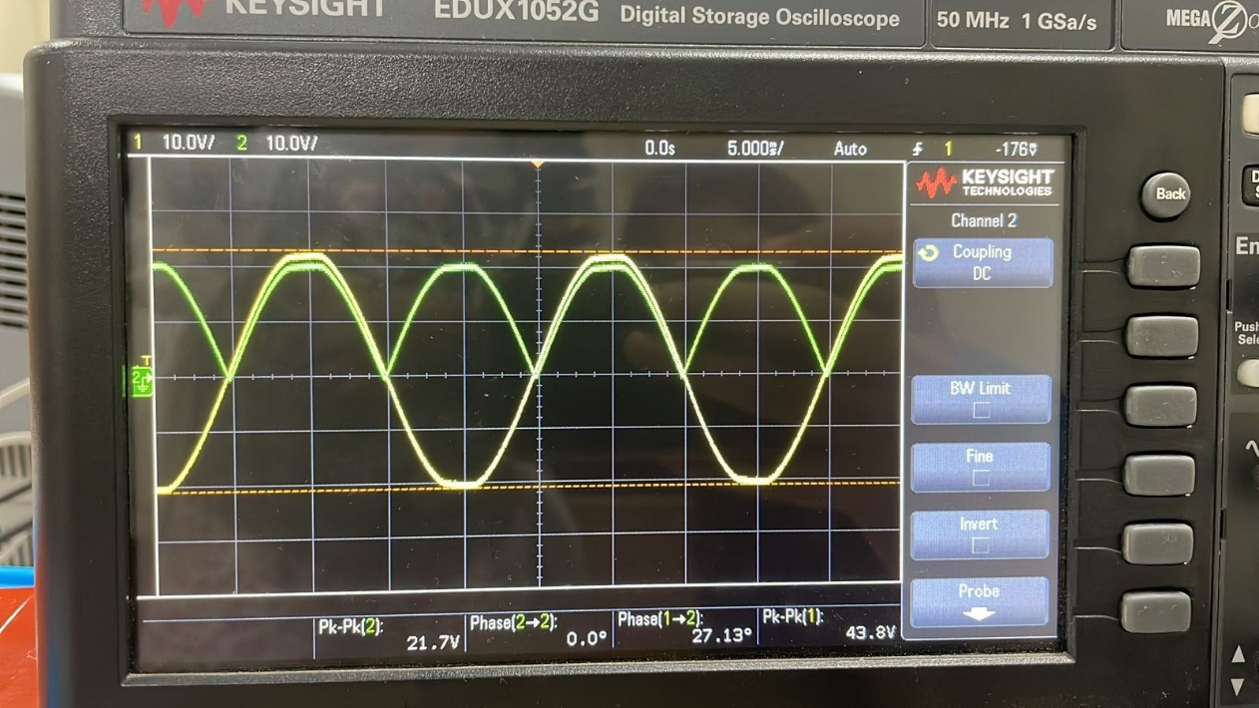

Vs1 = 43.8 / 2 V (yellow line)

= 21.9 V

Vout = 21.7/2 (green line)

= 10.85 V

Yes, we do observe better signal levels at Vout as compared to the previous case when funtion generator was used as an input source.

When we give a wall supply, the voltage at secondary is large enough, which allows the diodes to conduct fully in forward bias condition.

Because of this there is a high resolution and clarity in the output voltage.

**To conclude,**

The bridge rectifier is better than the center tap transformer.

This is because in the center tap transformer only half of the secondary coil is being used, because of which only half of the power received is being utilised.

But in the bridge rectifier the complete secondary coil is being used.

Further, the center tap transformer is much expensive and is not feasible.